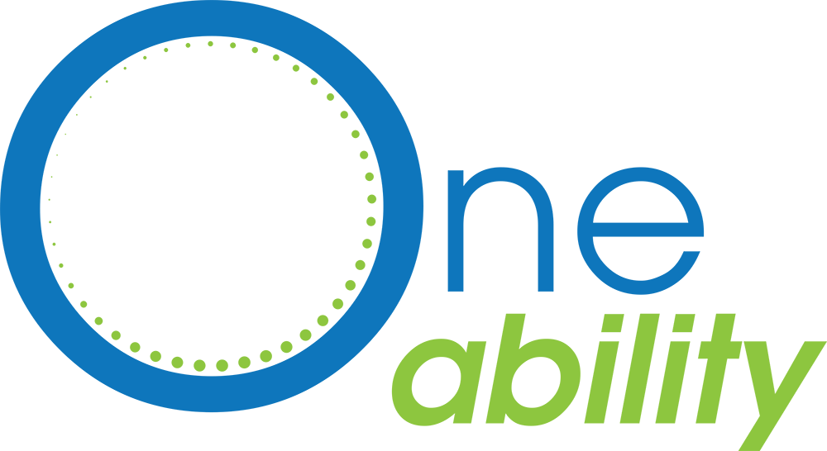

Program Delivery Fund

BACKGROUND

The allocation of a small amount of funds are available to assist OneAbility partners, active and affiliate members to support the promotion and facilitation of physical activity for individuals with a disability in the Capital Region. This may include, but are not limited: sport and recreation program costs, including facility fees, equipment, or staff; training opportunities for staff; COVID related programs and services; community event hosting, etc.

Organizations may request up to $500 to support their initiative.

Dates
Application Opens: August 1st, 2021
Application Deadline: September 1st, 2021
Applications Reviewed: September 1 -15, 2021
- Applications will be adjudicated by representation for the OneAbility Stewardship group.
Notifications of Successful Applicants by September 31st, 2021
Small Projects Reports due by February 15th, 2022*

*Project does not need to be completed by February 15th, but there needs to be evidence to demonstrate the impact of the project on OneAbility grant outcomes for the Victoria Foundation Grant Report.

Eligibility

- Must be a OneAbility Network Collaborator.
- Must be an organizational project (no individual projects will be accepted).
- Project outcomes must promote or enable physical activity for people with disabilities in the Capital Region.
- 2020 Recipients must submit their completed Small Projects Report form in order to be considered.
- Note: In the event of an excess of 2021 applications, new applications will be prioritized.

Desired Outcomes
- Increasing the number of opportunities available for persons with disabilities to be physically active (e.g., physical activity programs, classes, events, creation of physical activity infrastructure or environment).
- Increasing accessibility of physical activity programs, facilities, initiatives (e.g., adaptive programs to support individuals with varied abilities, improving inclusion practices, reducing cost barriers to physical activity).
- Improving physical or built environments to encourage more physical activity (e.g., infrastructure, active transportation routes).
- Increasing participation in physical activity (i.e., more people doing more physical activity).
- Building staff or community members & capacity to help others be physically active (e.g., staff or community training, supporting physical activity leadership, building skills or competencies to promote physical activity or physical literacy)
- Developing and implementing policies to encourage physical activity.
- Increased partnerships or collaborative programming opportunities.

How to Submit
Complete OneAbility Small Projects Application Form (pg 3-4) in Word OR Convert to Fillable PDF, and submit via email to Andrea Carey, oneabiltyvictoria@gmail.com by Midnight PST September 1, 2021.

Questions? - Contact Andrea Carey by email at oneabiltyvictoria@gmail.com

ONEABILITY SMALL PROJECTS APPLICATION FORM (2021)
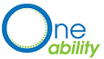
Organization Name: _______________________________________________________________________
Contact Name: _______________________________________________________________________
Contact Email Address: _______________________________________________________________________
Contact Phone Number: _______________________________________________________________________

Project Name: _______________________________________________________________________

Start and End Date of Project: _______________________________________________________________________

PROJECT OBJECTIVE
What do you aim to achieve and how does it align with OneAbility’s Vision, Mission and Outcomes?
____________________________________________________________________________________________________________________________________________________________________________________________________________________________________________________________________________________________________________________________________________________________________________________________________________________________________________________________

Is this a new or existing project? Please explain.
________________________________________________________________________________________________________________________________________________________________________________________________________________________________________________________________________________________________________

Other funders involved in this project (if any):
____________________________________________________________________________________________________________________________________________________

Other organizations participating in the activity (if any):
____________________________________________________________________________________________________________________________________________________

Amount Requested (up to $500): _________________________________________________________________

Describe how the funds will be used (i.e. Facility rentals, online delivery, COVID recovery, equipment, staff wages, etc)
__________________________________________________________________________________________________________________________________________________________________________________________________________________________________________________________________________________________________________________________________________________________________________________

Does your organization have any plans for sustaining the project or enhancing it in the future?
________________________________________________________________________________________________________________________________________________________________________________________________________________________________________________________________________________________________________

ONEABILITY SMALL PROJECTS REPORTING FORM (2021)

Organization Name: _______________________________________________________________________
Contact Name: _______________________________________________________________________
Contact Email Address: _______________________________________________________________________
Contact Phone Number: _______________________________________________________________________

Project Name: _______________________________________________________________________

Start and End Date of Project: _______________________________________________________________________

PROJECT OBJECTIVE
(please check all that apply and describe how your project achieves the selected outcome/s)

- Increasing the number of opportunities available to be physically active (e.g., physical activity programs, classes, events, creation of physical activity infrastructure or environment).
- Increasing accessibility of physical activity programs, facilities, initiatives (e.g., adaptive programs to support individuals with varied abilities, improving inclusion practices, reducing cost barriers to physical activity).
- Improving physical or built environments to encourage more physical activity (e.g., infrastructure, active transportation routes).
- Increasing participation in physical activity (i.e., more people doing more physical activity).
- Building staff or community members & capacity to help others be physically active (e.g., staff or community training, supporting physical activity leadership, building skills or competencies to promote physical activity or physical literacy).
- Developing and implementing policies to encourage physical activity.
- Increased partnerships or collaborative programming opportunities.
_____________________________________________________________________________________
_____________________________________________________________________________________
_____________________________________________________________________________________
_____________________________________________________________________________________
_____________________________________________________________________________________
_____________________________________________________________________________________
_____________________________________________________________________________________

POPULATION
How many individuals were impacted by your project? _______________________________________

Age Groups?
- Early-Aged (0-5 yrs)
- Children (6-12 yrs)
- Youth (13-18 yrs)
- Adults (19+)
- Older adults (65+)

How many of these individuals have a disability?_______________________________________
Types of Disabilities?__________________________________________________________________

PROJECT
What barriers/challenges have you encountered during the implementation of this project?
_____________________________________________________________________________________
_____________________________________________________________________________________
_____________________________________________________________________________________

Evidence of project’s success to date (Attach to form)
- Participant Testimonials/Quotes (Participants, Parents/Caregivers)
- Photos (With Photo-Consent)
- Videos (With Video-Consent)
- Media Release
- New Resources
- Other (please specify)

Is sustainability of this project (and/or the project outcomes) something your organization is working toward? How?
_____________________________________________________________________________________
_____________________________________________________________________________________
_____________________________________________________________________________________

Is there anything else you’d like to share with OneAbility?
_____________________________________________________________________________________
_____________________________________________________________________________________
_____________________________________________________________________________________

